**Title: Installation and demonstration of sawmill on windows OS. Generate a custom report.**

**Objective:**

The objective of this experiment is to install and demonstrate the usage of Sawmill on a Windows operating system, specifically for generating a custom report.

**Some information about “Sawmill”:**

Sawmill software is used for log analysis and reporting, providing insights into website traffic and user behaviour. It processes log files and generates customizable reports, helping administrators and marketers understand website performance and security-related information.

**Requirements:**

Sawmill installer

**Procedure/Experiment Steps:**

1. Download the latest version of the Sawmill software from the official website.
2. Launch the installer and follow the on-screen instructions to install Sawmill on the Windows OS.
3. Once the installation is complete it ask for first time Configuration detail like Language, Licence agreement, username and password we need to set for the first time.

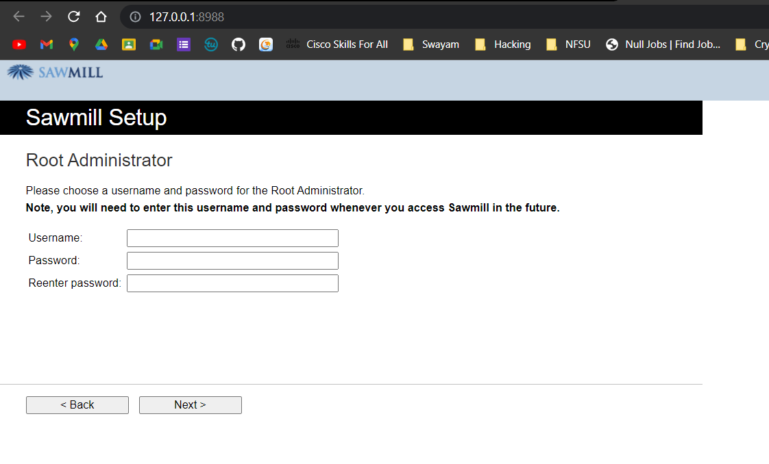

1. Configure the necessary settings, such as specifying the log file or data source for analysis.

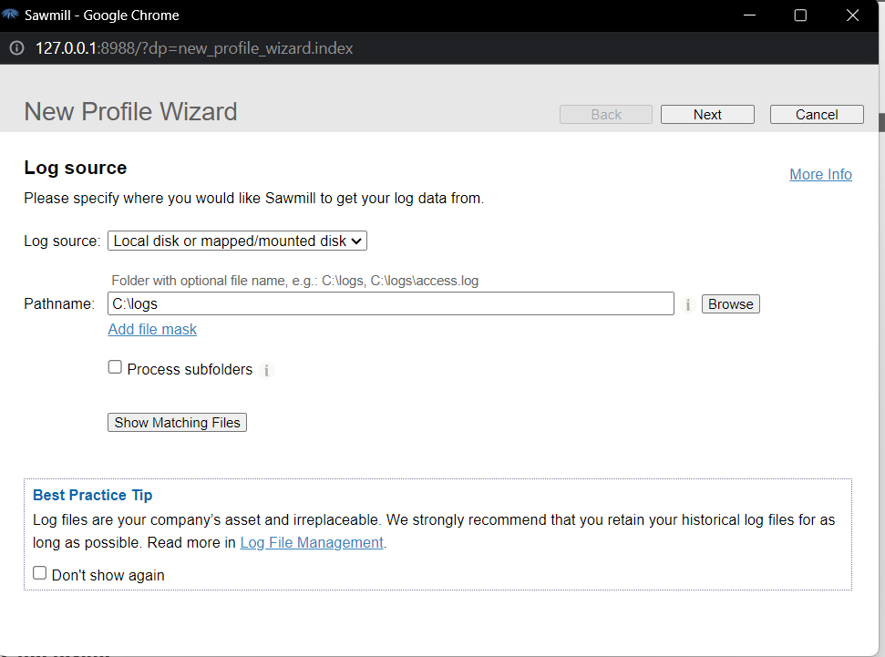

1. Choose log file format to import the log data.

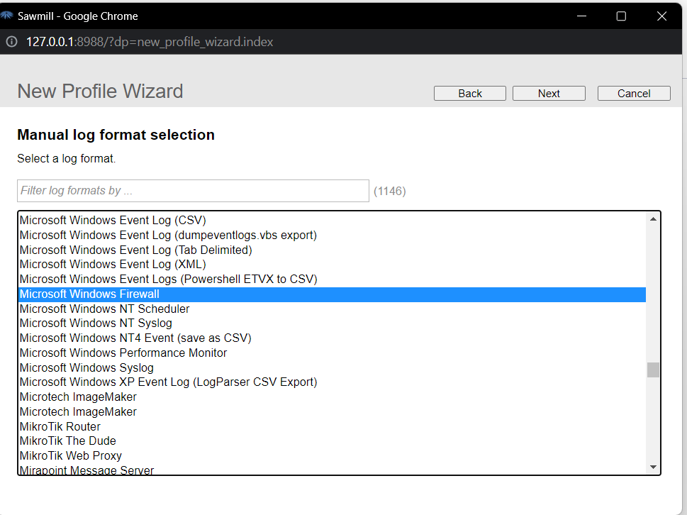

1. Set the appropriate log file parameters, including file location, log format, and any specific customization options.

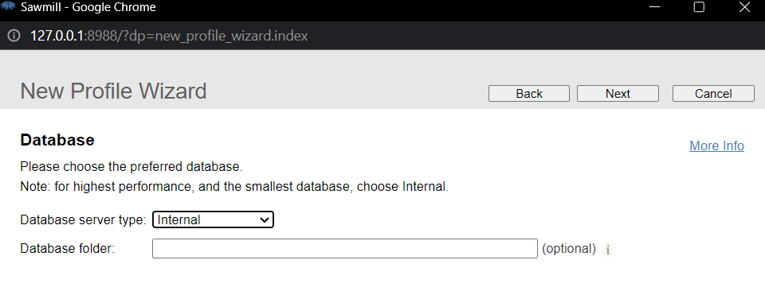

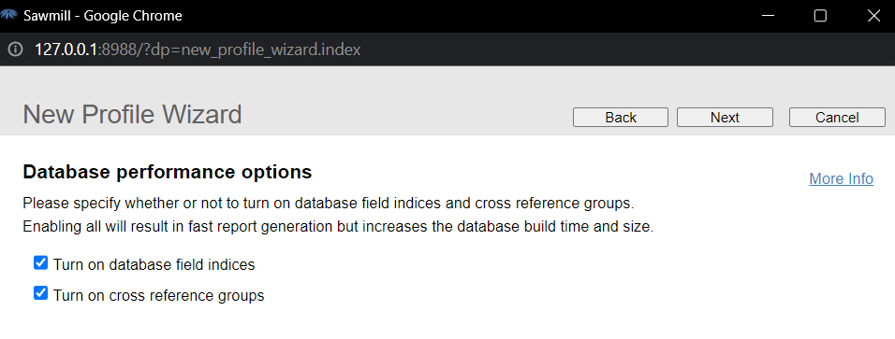

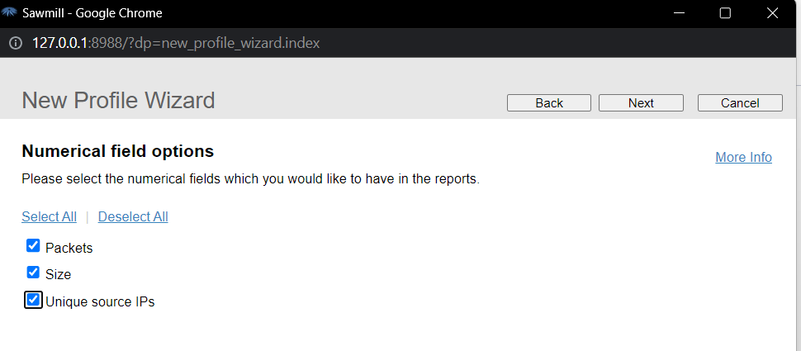

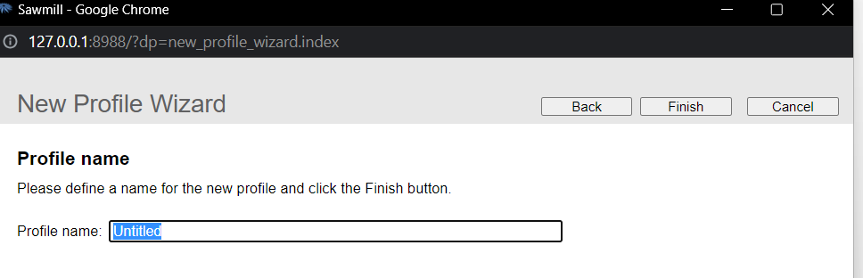

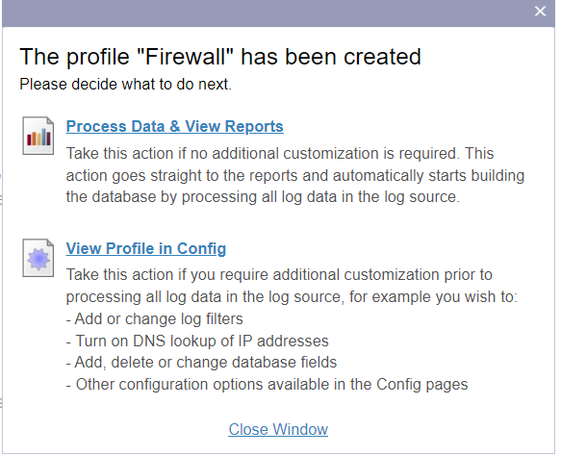

1. Initiate the log data import process to populate the Sawmill database.
2. Once the data import is complete, navigate to the reporting section within Sawmill.
3. Select the desired report customization options, including specific data fields, filters, date ranges, and visualization preferences.

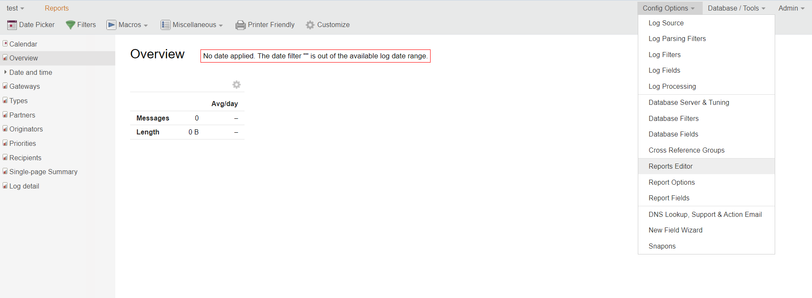

1. Generate the custom report based on the selected parameters.

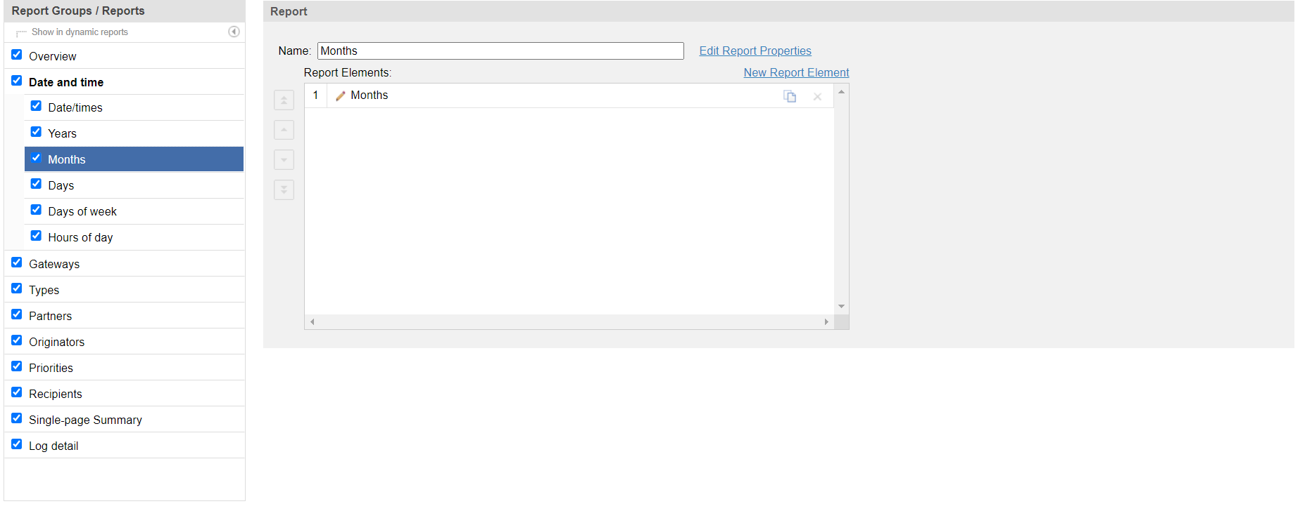

1. Review and analyze the generated custom report for insights and information.

**Result:**

The custom report generated from Sawmill provides valuable insights and analysis based on the selected parameters. It allows for in-depth exploration and understanding of the log data, assisting in identifying patterns, anomalies, and trends.

**Conclusion:**

The installation and usage of Sawmill on the Windows operating system enable the generation of custom reports, offering an effective approach to analyse and interpret log data. The custom report assists in understanding the logged information, identifying important trends, and making informed decisions.

**Future Scope:**

1. Exploring advanced customization options within Sawmill to generate more specific and targeted reports.
2. Integrating Sawmill with other security tools or log sources to consolidate and analyze data from multiple sources.
3. Conducting further research on log analysis methodologies and techniques to enhance the effectiveness of Sawmill reports.